LAB 2

TITLE: Implementation of FCFS (First-Come, First-Served) Scheduling Algorithm in C.

OBJECTIVE: To implement the First-Come First-Served (FCFS) CPU scheduling algorithm and calculate:

Waiting Time (WT)

Turnaround Time (TAT)

Average Waiting Time

Average Turnaround Time
THEORY:
FCFS is the simplest CPU scheduling algorithm. In this method, the process that arrives first is executed first. It's a non-preemptive algorithm.

🔸 Characteristics:
- Processes are scheduled in the order of arrival.
- It may suffer from the convoy effect (i.e., short processes waiting behind long ones).
- Easy to implement and understand.

🔸 Terminologies:
- Burst Time (BT): Time required by a process to complete execution.
- Waiting Time (WT): Total time a process has to wait before getting CPU.
  - WT[i] = ∑ BT of all previous processes
- Turnaround Time (TAT): Total time taken from arrival to completion.
  - TAT[i] = WT[i] + BT[i]
- Average Waiting Time (AWT):
  - AWT = ∑WT / n
- Average Turnaround Time (ATAT):
  - ATAT = ∑TAT / n

Algorithm:
- Start the program
- Input number of processes n
- Input burst time for all n processes
- Set WT[0] = 0
- Calculate waiting time for each process:
- WT[i] = WT[i-1] + BT[i-1]
- Calculate turnaround time for each process:
- TAT[i] = WT[i] + BT[i]
- Calculate average WT and TAT
- Display results
- End

PROGRAMS
#include<stdio.h>

int main() {
int n, i, j;
float bt[20], wt[20], tat[20];
float avwt = 0, avtat = 0;

printf("Enter total number of processes: ");
scanf("%d", &n);

printf("\nEnter Process Burst Time\n");
for(i = 0; i < n; i++) {
printf("P[%d]: ", i+1);
scanf("%f", &bt[i]);
}

wt[0] = 0;
for(i = 1; i < n; i++) {
wt[i] = 0;
for(j = 0; j < i; j++)
wt[i] += bt[j];
}

printf("\nProcess\t\tBurst Time\tWaiting Time\tTurnaround Time");
for(i = 0; i < n; i++) {
tat[i] = bt[i] + wt[i];
avwt += wt[i];
avtat += tat[i];
printf("\nP[%d]\t\t%.2f\t\t%.2f\t\t%.2f", i+1, bt[i], wt[i], tat[i]);
}

avwt /= n;
avtat /= n;

printf("\n\nAverage Waiting Time: %.2f", avwt);
printf("\nAverage Turnaround Time: %.2f", avtat);

return 0;
}

Output:

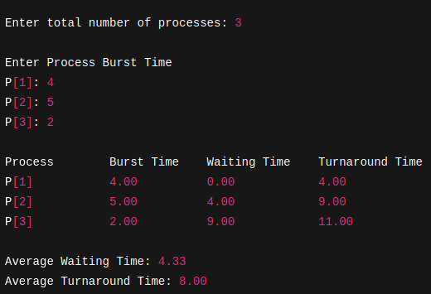

RESULTS:
The FCFS scheduling algorithm was implemented successfully. The program calculated the waiting time, turnaround time, and their averages for all processes.

CONCLUSION:
FCFS is a basic CPU scheduling technique. This lab helped in understanding:
- How processes are handled in the order of arrival
- How to calculate process scheduling metrics like WT and TAT

